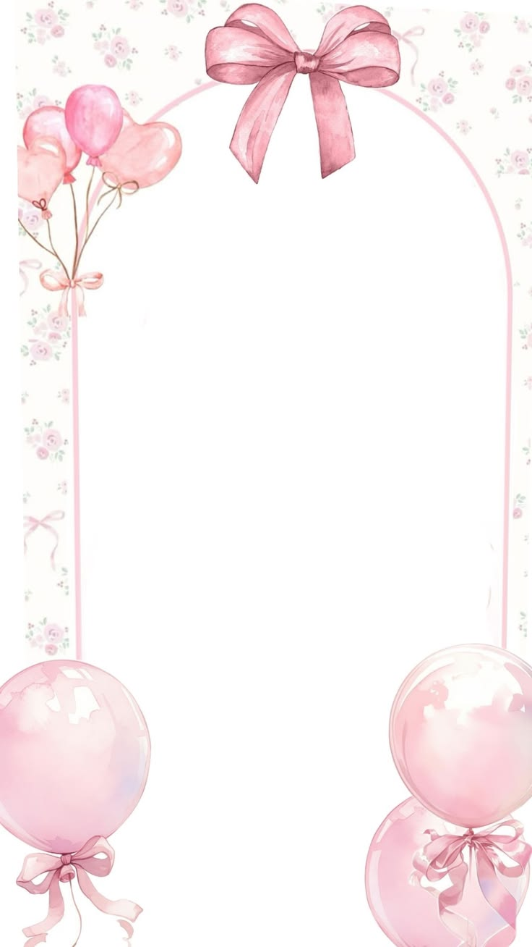
HAPPY BIRTHDAY…!!
May this year bring you
closer to your dreams and fill
your life with unforgettable
moments. I hope this card brings you love, A smile on your face and happy vibes throughout your special day.

